**Project Development Phase**

**Sprint-1**

**1.Design of Mobile App UI with login feature for getting sensor values** Frontend Design Screen 1:

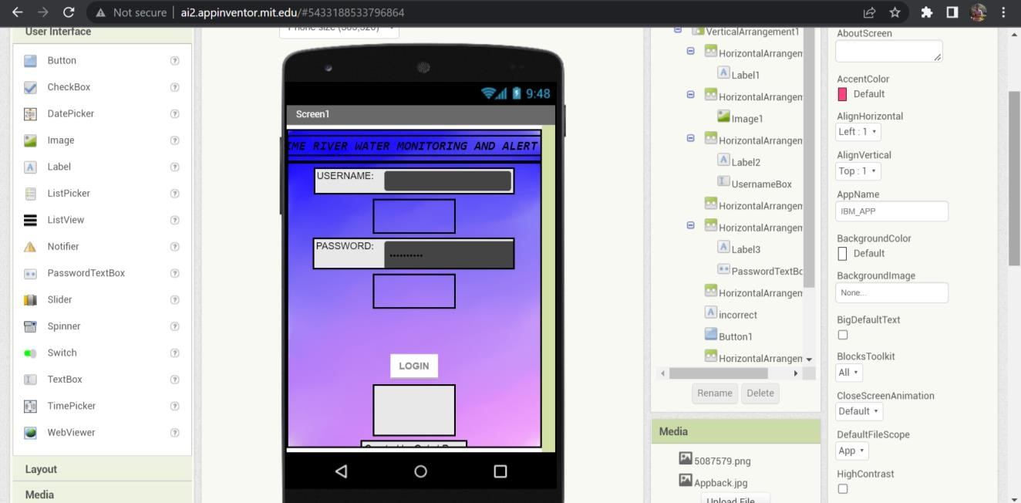

Frontend Design Screen 2:

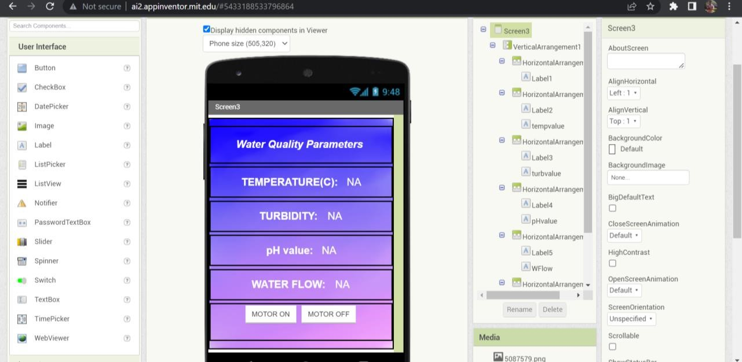

Backend :

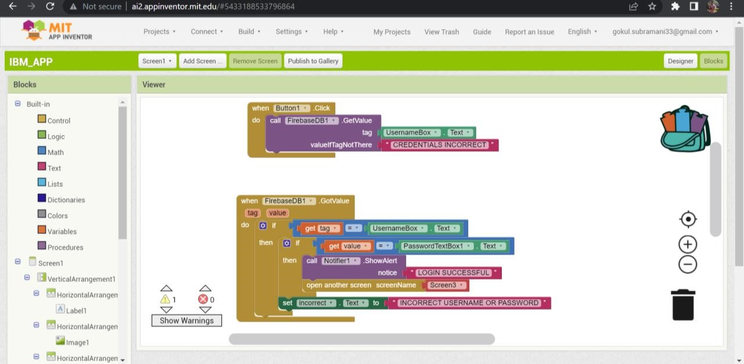

Firebase db for storing login credentials:

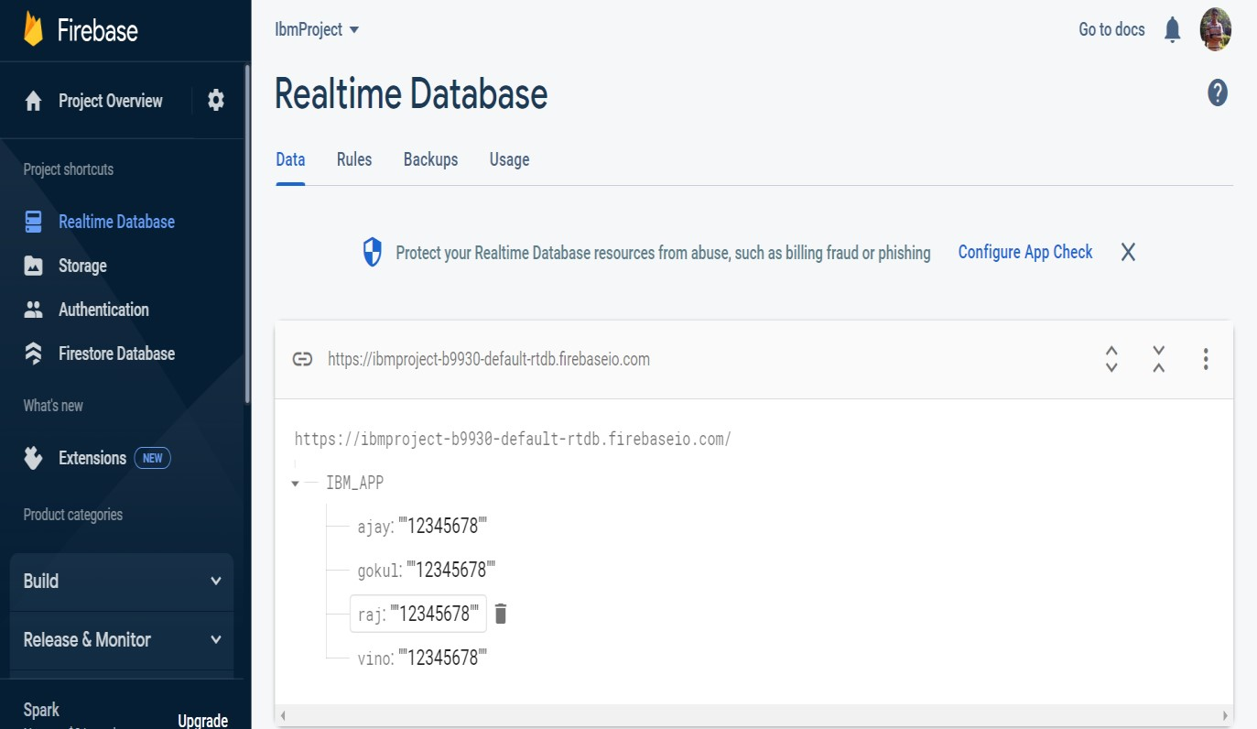

**Testing the designed app:**

1.Incorrect login information are tested.

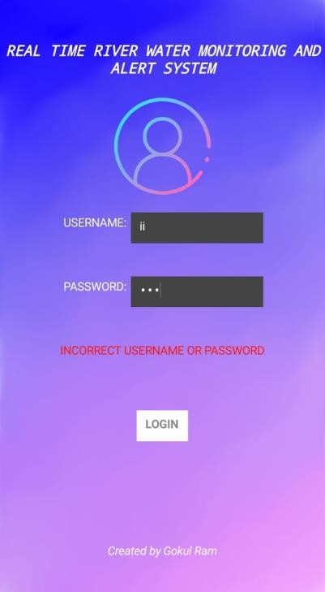

2.Upon successful login

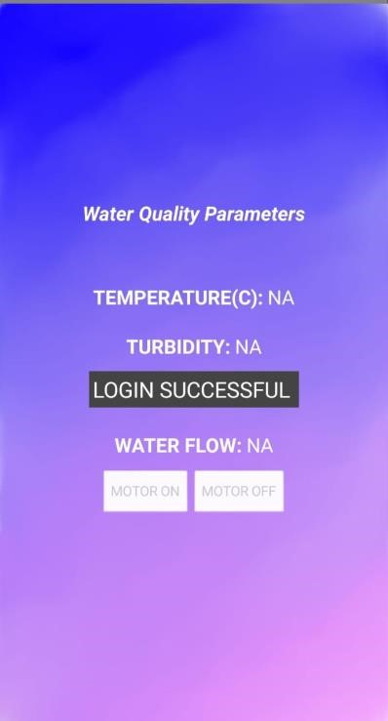

3.Display of different sensor values

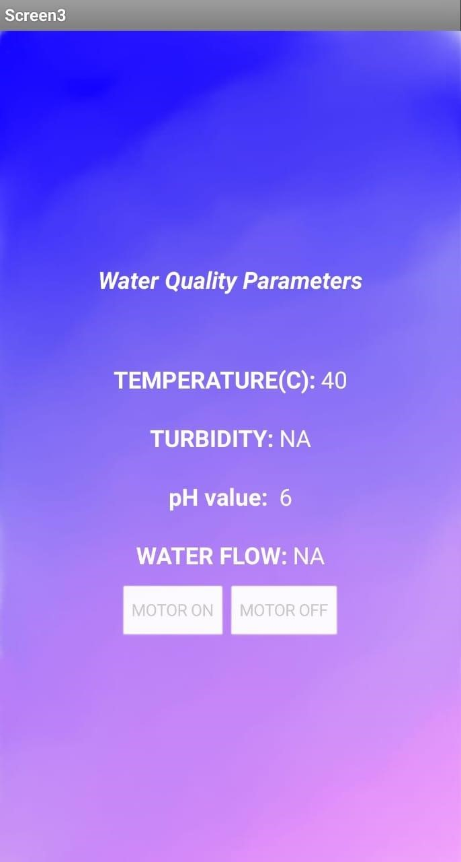

**Mobile App Link:**

[https://drive.google.com/drive/folders/1lXT8hK-lkAKTQVSC1dfl1abOKL45kl5?usp=share_link](https://drive.google.com/drive/folders/1lXT8hK-lkAKTQVSC1dfl1ab-OKL45kl5?usp=share_link)